Drug related deaths – advice on improving toxicology, especially nitazenes

FAO: Autopsy pathologists and forensic pathologists

This update should be seen as complementary to the RCPath autopsy guidelines on Autopsy when drugs or poisoning may be involved, September 2024. It includes advice for pathologists on autopsy toxicology sampling to improve detection rates of new drugs.
Representatives of the RCPath Death Investigation Committee recently met with colleagues from the Office for Health Improvement and Disparities (OHID) who are conducting a project to collect information on toxicology testing to better inform national surveillance of drug trends, particularly with regard to new and emerging drugs.
We are aware of synthetic opioids such as nitazenes being found in illicit drugs including heroin, cocaine, benzodiazepines and illicit oxycodone. Nitazenes are highly potent drugs and hence pose a significant public health threat. The table below shows some approximate relative potencies in comparison to heroin but this a complex area so this is only indicative of the increased risk.
Table 1. Approximate nitazene potency in comparison to heroin
Heroin | 1
Fentanyl | 50
Metonitazene | 50
Protonitazene | 100
Isonitazene | 250
Etonitazene | 500

Nitazenes are unstable in blood
The detection of nitazenes is difficult in post mortem blood and it is well recognised that nitazenes are unstable in blood. This may mean that these drugs are not being detected in routine testing.
It is recommended that pathologists liaise with their toxicology laboratory to ensure the right testing is being carried out in any death suspected to be related to illicit drug use, and that the samples provided to the laboratory are appropriate and timely.
We would recommend the use of preserved blood wherever possible. A sample of preserved blood should always be sent for toxicology testing. However, with the aim of detecting nitazenes more accurately, we recommend sending a larger volume of preserved blood (using two or more bottles, or bottles of larger capacity) if available. In addition, preserved urine is also recommended whenever it is available. Nitazenes may be detectable in the urine, and 6-MAM detection in urine can be helpful in heroin related deaths.
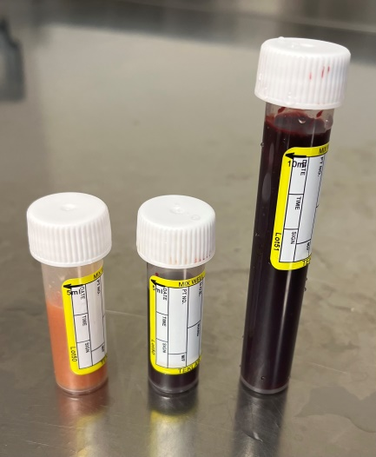 5ml and 10ml preserved blood, 5ml preserved urine

Consideration should be given to taking blood and urine samples as early as possible after the death, (following the Coroner’s/Procurator Fiscal’s instruction) to reduce degradation.
Nitazenes may also be linked to deaths among people who do not use heroin
In many cases where nitazenes have been detected in post mortem samples there is either also toxicology evidence of heroin use or a known history of heroin use. It is not uncommon to see deaths occurring very rapidly after injecting, with the needle still in the injection site or in the hand.
However, in a substantial minority of cases there is no evidence that the deceased had ever used heroin. In many such cases, the deceased may have died after taking what they believed was cocaine, oxycodone or a benzodiazepine, in a recreational or medicinal use context. We recommend testing for nitazenes in all cases where there is no anatomical cause of death or where the deceased may have taken counterfeit pharmaceuticals or recreational drugs.
Information to provide to the toxicology laboratory
It is good practice to send the toxicology laboratory relevant information about the death, circumstances, scene and medical/drug history. Ideally the information from the Coroner’s/Procurator Fiscal’s instruction should also be sent. Additional information that may inform testing strategies should be specifically highlighted and includes:
- If the deceased was homeless
- If the deceased died in prison (synthetic cannabinoids may also be implicated)
- If oxycodone-like tablets are present at the scene
Interpretation and cause of death
Interpretation of toxicology reports can be difficult with new and emerging drugs where there is little data on “normal” ranges. In the case of nitazenes, the current UK experience shows these are forming part of a mixed drug toxicity cause of death (rather than one drug on its own). Given the potency of nitazenes and the degradation of the drugs in blood, it is entirely reasonable, if a nitazene has been detected in the blood or urine, to include this in the cause of death. The wording of the cause of death should specify the drugs implicated to ensure good national statistics on drug related deaths. For example:
1a. Mixed drug toxicity – heroin, etonitazene, methadone and phenazepam

